DBMS Mini Project Synopsis

Hospital Management System

Name – Hrishikesh Athalye
MIS - 111803154
Class – TY Comp (Sem 5)
Div - 2

Problem Statement
Developing a hospital management system in order to effectively manage most aspects of hospitals such as booking appointments, managing patient records and keeping medical history.

Overview
Organisations such as hospitals have to deal with a lot of patients regularly and hence a lot of data. Hence it is very important for a hospital to have a DBMS with a frontend that easily allows patients to book appointments and allows doctors or administrators to manage patient data.
For this project I have chosen to build the frontend using ReactJS and JavaScript, backend in Node.js and the database used will be MySQL.

Functional Requirements
- Separate interfaces for patients and doctors. Patients and doctors should have separate logins.
- Allow patients to book appointments and view/update/cancel them later if necessary, creating free slots for other patients.
- Allow doctors to cancel appointments.
- The system should avoid clash of appointments and allow appointments only when a doctor is not already busy or does not have a break.
- Doctors should be able access patient history and profile, and add to patient history.
- Doctors should be able to give prescriptions and diagnosis.

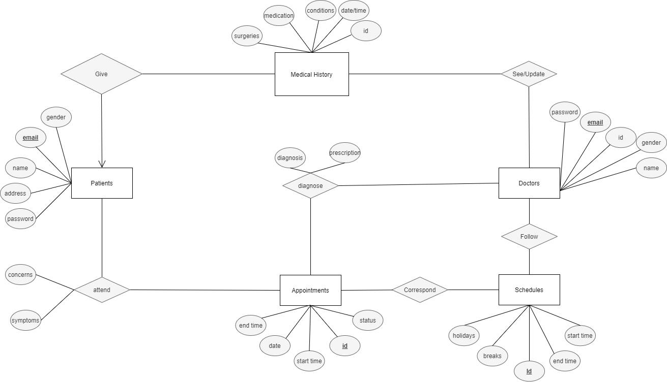
ER Diagram

Relational Schemas
- Patient
Email | Password | Name | Address

- Doctor
Email | Gender | Password | Id | Name

- Medical History
Surgery | Medication | Condition | Date/Time | Email

- Appointment
Id | Date | Start | End | Status

- Schedules
Id | Start | End | Holidays | Breaks

- Diagnose
Appt Id | Doctor | Diagnosis | Prescription

